Schedule of Events
Winter/Spring 2007
Two guided nature walks with a puddle jumpers program will be offered winter and spring. Watch newspaper and website for details.

Puddle Jumpers, for 3-6 year olds, nature walk and scavenger hunt, for all else a nature walk throughout the Cedar Meadow Preserve, accompanied and unaccompanied.

Catawba island Township Board of Trustees
(419) 797-4131
Gary Mortus
Bill Rofkar
Bob Schroeder

www.catawbaislandtownship.com

Catawba Island Township Park Board
(419) 797-4131
JohnSmothers
Meridith Beck
John Copeller
It’s Official
If you would like periodic email updates of activities at CMP send an email to thomasa@muohio.edu
By Catherine Pfeiffer
The former Vollmer property, now a Township preserve, has been officially named the Cedar Meadow Preserve.
Purchased in 2005 by Catawba Island Township, with assistance from the Clean Ohio Fund and the Black Swamp Conservancy, the Cedar Meadow Preserve is over 62 acres of mixed meadow, forest and wetland. It sits behind the Township offices and fire hall, adjacent to both Northeast Catawba Road and West Catawba Road. It was, at the time of purchase, the largest remaining parcel of land available for preservation on Catawba – unbroken by backyards and roads and buildings.
Entering the preserve from Cemetery Road (park in the fire station lot), at the base of the water tower, the visitor encounters an old farm with orchards, walnut groves, overgrown fields, hedgerows and a large vernal pond. Once belonging to the Smith family, the farmstead is long gone and the cistern has been filled in; only the old windmill still stands. The dooryard plants have naturalized, the walnut and cedar trees have matured, and the orchards have fallen due to neglect. Invasive and alien plants are bullying their way across the land, poison ivy waits for a visitor’s misstep, and in summer, the wetlands woods belong to hungry insects.
Yet every part of this preserve offers treasures to the visitor – human and animal both. In the first year of exploring and managing the preserve, the park board, volunteers, and visiting naturalists have marveled at the plant and animal diversity. There are now about a mile of rough paths through some of the land, marked out by the naturalists and mowed by the Township. Volunteers have logged many hours identifying birds and butterflies and plants. In every season, there have been new discoveries of the value of this land, finding its way back from cultivation to a natural tangle of plants both native and alien. It is not virgin or pristine, but it is a remnant of the 100 year flood plain of the Erie Islands. It was cultivated for decades, but it was stewarded according to methods long-thought to be proper. Perhaps its greatest asset is that it is positioned for birds making the long flight over Lake Erie – on chilly days in April, waiting for the warm southwest wind, birds congregated in this place, gathering strength for the big jump across. And on a warm day in October, the birds were there again, having flown in from the north.
What is the plan for this preserve? How will animals and plants and people share this treasure on Catawba? That will be the responsibility of the Township Trustees, with the advice and assistance of its park board. And in turn, the park board seeks input from volunteers and professional naturalists.
Two of the most helpful volunteers have been Julie and Mark Shieldcastle, who conducted naturalist walks on Earth Day last spring; over 75 people walked with them through the woods and fields, learning firsthand what was on the preserve and how important it will prove to be. Mark is a

Wildlife biologist with the Ohio Division of Wildlife, Department of Natural Resources, at Crane Creek State Park; Julie is the Executive Director of the Black Swamp Bird Observatory.
Volunteer lepidopterists, in weekly summer walks, identified 22 species of butterflies inhabiting the preserve – this far outnumbers the species count in less diverse environments and indicates a strong plant and animal community. There have been first attempts at cataloguing the plants living in the preserve, although only from the mown paths; a full catalogue waits for access to remote sections of the preserve and for sufficient volunteer help.
Volunteers were immediately helpful when the weather broke last spring; in early April, 15 hardy folks worked under the park board’s guidance in a clean-up of the old farmstead dump. A full dumpster of household items and old farm implements was carted away, along with evidence that the area had been used for paintballing!
There are several trail improvements in place, including stone, culverts and boards to cross wet or muddy sections of the trail. The park board is considering a boardwalk for certain areas. Benches have been situated; more are planned. There are a few signs, posting the area against trespassing and hunting. A map is available at the Township Zoning Office, although following any of the paths will lead the visitor back to the water tower.

The next year will see the development of a management plan for the preserve; Mark Shieldcastle will help with this. His questions will guide the park board to consider the alternatives for managing the property, and the board will solicit input from Catawba Island citizens. Any habitat restoration of the property will require volunteer help; already the park board has a list of 15 folks it can call on, although that number will undoubtedly increase this next year. Volunteers will be needed for monthly clean-up days, for plant and animal identification, for invasive species control and eradication, for trail maintenance, and for wildlife surveys (plant and animal).
Throughout the newsletter are quick-access lists of facts about Cedar Meadow Preserve and some of the information about it gleaned this first year. Please visit the preserve, enjoy its diversity and specialness, and let us know that you will be able to volunteer in some way to help with the next steps in its management. Call the Township office at 419-797-4131 or e-mail the Catawba Island Township at zoning@catawbaislandtownship.com and leave your name, address and telephone number and a note about how you would like to help. Ask questions, be available for meetings, visit the preserve, let us know what you would like to have happen. And let us know what you see.

----------

Eastern redcedar (Juniperus virginiana)

“A slow-growing, hardy native tree that thrives naturally as far south as Georgia and west to Minnesota. The fruit ripens in early fall and persists through winter. Only the female plant produces the blue, berry-like cones. It grows to a height of 50 feet. Redcedar attracts at least 54 species of birds that are known to eat the fruit, including cedar waxwing, brown thrasher, gray catbird, eastern blue bird, purple finch, cardinal, fox sparrow, tree swallow.” Stephen Kress, National Audubon Society, The Bird Garden.

“One of the best of all evergreens for songbirds because it provides food, shelter and nesting cover.” John K. Terres, Songbirds in Your Garden.

What are some things to see on the Cedar Meadow Preserve

Invasive species observed on Cedar Meadow Preserve

Garlic mustard
Multiflora rose
Canary reed grass
Russian olive
Japanese honeysuckle
Gray dogwood

Trees observed
Eastern redcedar

White Oak

Pin Oak

Red Oak

Chinhapin Oak

Hackberrry

Basswood

Cottonwood

Ironwood
Hickory
Tulip tree
White ash
Elderberry
American cherry

Plant species observed
Violets
Sweet Cecily
False Solomon’s seal
Jack- in- the- pulpit
Blue eyed grass
Blackberry
Common cinquefoil
Wild raspberry
Lance goldenrod and Canada goldenrod
Wild species rose
Ironweed
Tickseed trefoil
Big blue stem grass
May apple
Hairy vetch
Venus looking glass
Sensitive fern
Red clover
Fleabane
Common & swamp milkweed
Wild black cherry
Button bush
Jewelweed
Woodland sunflower
White clover
Self-heal
Queen Anne’s lace
Snakeroot
Wild blue lettuce
New England aster
Ball thistle
Evening primrose
Poison ivy
Wild strawberry
Star of Bethlehem

Animals observed
Great horned owl
Garter snake
Saw whet owl
Fox snake
Woodcock
Warblers
Crayfish

Butterfly species observed
Cabbage white
Black swallowtail
Mourning cloak
Monarch
Pearl crescent
Eastern comma
Spring azure
Red admiral
Orange sulfur
Little wood satyr
Tiger swallowtail
Red spotted purple
Silver spotted skipper
Zabulon skipper
Eastern tailed blue
Hackberry
Wood nymph
Banded hairstreak
Clouded sulfur Giant swallowtail

Cedar Meadow Preserve Rules
√ Preserve is open from dawn to dusk.
√ Follow designated trails and paths. Stay clear of private property.
√ Do not remove items from natural areas. Leave flowers, plants and animals for others to enjoy. Never knowingly disturb wildlife.
√ Leave only footprints. Do not litter.
√ Bring your family. Motorized vehicles, firearms, alcohol and drugs are prohibited.
√ No camping, fires, or hunting.
√ Dogs on leashes are welcome. Please remove all dog droppings.
√ Have fun and enjoy the outdoors
Black Swamp Conservancy
A land trust with headquarters in Perrysburg, Ohio. It encourages the conservation and protection of natural areas and farmland in northwest Ohio for the benefit of current and future generations. Their staff prepared the application for Clean Ohio Coonservation Funds that resulted in a $771,395 grant to facilitate the purchase of the Vollmer property. They may be contacted at P.O. Box 332, Perrysburg, Ohio 43552-0332. Telephone 419-872-5263. E-mail bsc@blackswamp.org.

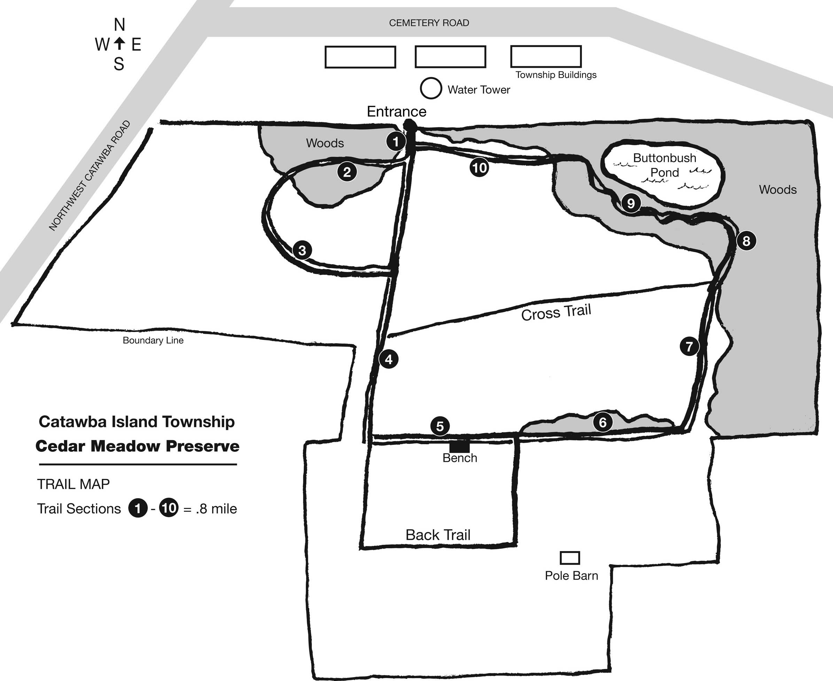
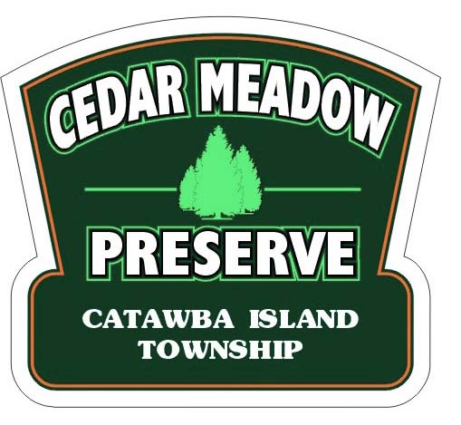
U.S Postage
Catawba
Third Class
No. 434

